Tow/Haul Telltale – CGEA1.3

Functional Description

The purpose of the Tow/Haul Telltale is to inform the driver that the Tow Haul system has been engaged and is actively providing Tow Haul control of the vehicle.

The Tow_Haul_Telltale correlates the PtDrvMde_D_Stat signal and the Operational_Mode to illuminate or extinguish the Tow_Haul_Telltale.

The Tow_Haul_Telltale shall provide an iconic representation that will illuminate or extinguish to inform the driver that the Tow Haul Feature is on or off as selected by the vehicle operator.

Interfaces

Interface Context Diagram (I/O Block Diagram)
- Tow Haul Indication
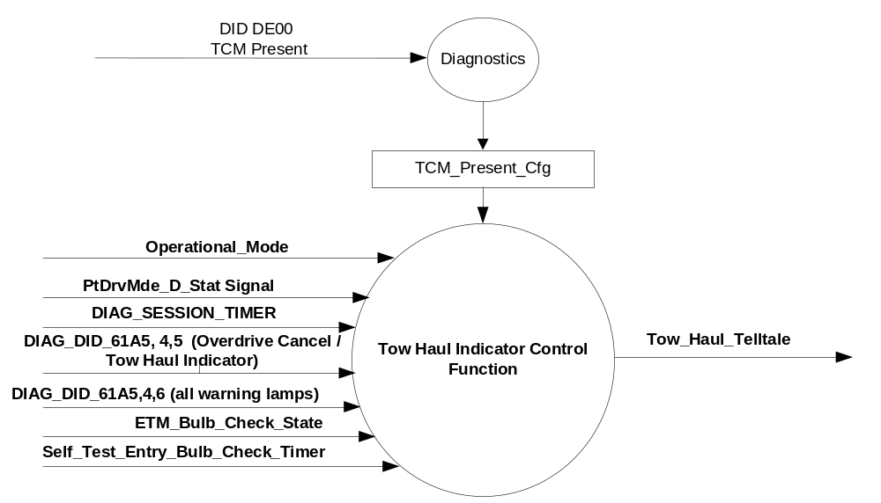

Inputs

      - INTERNAL:
            - DIAG_SESSION_TIMER
            - Operational_Mode
            - DIAG_DID_61A5,4,6 (all warning lamps)
            - DIAG_DID_61A5,4,5 (Overdrive Cancel Lamp / Tow Haul)
            - ETM_Bulb_Check_State
            - Self_Test_Entry_Bulb_Check_Timer
      - MUX message on the CAN Bus from ECM/PCM

- PtDrvMde_D_Stat Signal
Signal Name | Size  (bits) | Detail | Units | Res. | Offset | State  Encoded | Min. | Max.
PtDrvMde_D_Stat | 3 |  | SED | 1 | 0 |  | 0  (0x0) | F  (0xF)
 |  | Normal |  |  |  | 0x0
 |  | Sport |  |  |  | 0x1
 |  | SnowWet |  |  |  | 0x2
 |  | TowHaulGradeAssist |  |  |  | 0x3
 |  | NotUsed1 |  |  |  | 0x4
 |  | NotUsed2 |  |  |  | 0x5
 |  | NotUsed3 |  |  |  | 0x6
 |  | NotUsed4 |  |  |  | 0x7
 |  | NotUsed5 |  |  |  | 0x8
 |  | NotUsed6 |  |  |  | 0x9
 |  | NotUsed7 |  |  |  | 0xA
 |  | NotUsed8 |  |  |  | 0xB
 |  | NotUsed9 |  |  |  | 0xC
 |  | NotUsed10 |  |  |  | 0xD
 |  | NotUsed11 |  |  |  | 0xE
 |  | Faulty |  |  |  | 0xF

Outputs
Tow_Haul_Telltale, which is used to control the state of the LED

Function/Performance

Operational Modes

Mode | Differentiating Vehicle Conditions
Sleep Mode | Tow/Haul Telltale OFF
Limited Mode | Tow/Haul Telltale OFF
Normal Mode | Tow/Haul Telltale ON/OFF
Crank Mode | Tow/Haul Telltale ON/OFF

Voltage Levels

Refer to the Cluster Features table located in the Operational Modes and Voltage Range Strategies Section in this SPSS

Human-Machine Interface

Visual

Indicator Graphics / Display Format
TOW
HAUL

For actual symbol definition refer to database # TBD of the 03-0685 ARL requirement

Indicator Color Coordinates
Amber - Reference SDS IL-0017/IS-0379

Indicator Characteristics
LED - Tow/Haul Telltale

Audio

None.

System Accuracy

The Tow_Haul_Telltale shall change the state of the Telltale within 100msec of a state change as indicated in the state matrix reference 1.3.5.1 Subsystem Algorithm Flowchart/ State Diagram.

Operation: Performance and Functional

Subsystem Algorithm Flowchart / State Diagram

- State Matrix for Tow Haul Telltale
Operational_Mode | ETM Bulb_  Check_State | DIAG_  SESSION_  TIMER | Self_Test_ Entry_  Bulb_ Check_Timer | DIAG_DID  _61A5,4,5 (Overdrive Cancel./TowHaul  indicator) | DIAG_DID_  61A5,4,6  (all warning  lamps) | PtDrvMde_D_Stat  Signal | Tow_Haul_  Telltale
Normal or  Crank | X | Not Active | X | X | X | TowHaulGradeAssist (0x3) | ON
Normal or  Crank | X | Active | X | Not Received | Not Received | TowHaulGradeAssist (0x3) | ON
Normal or  Crank | X | Active | X | ON (0x1) | X | X | ON
Normal or  Crank | X | Active | X | X | ON (0x1) | X | ON
Normal or  Crank | X | Active | Active | X | X | X | ON
Normal or  Crank | ON (0x1) | Not Active | X | X | X | X | ON
Normal or  Crank | OFF (0x0) | X | Not Active | Not Received | Not Received | Missing as per 1.4.1 | OFF
All Other Cases |  |  |  |  |  |  | OFF
X = Don’t Care
Not Received = The state when a DIAG_SESSION_TIMER is active and the DID has not been received

Operation Description (supports algorithm flowchart /state diagram)

- Tow_Haul_Telltale shall default to OFF when transitioning from Sleep or Limited to Crank or Normal until receipt of PtDrvMde_D_Stat Signal.
- Tow_Haul_Telltale shall reflect signal state within 150 ms of receipt of PtDrvMde_D_Stat Signal.
- PtDrvMde_D_Stat signal used in this STSS replaces TrnShifMde_D_RqDrv signal used in prior version (v1.0) If a particular program does not support PtDrvMde_D_Stat signal then use prior version (v1.0) of this STSS.

Function Safety Classification (EMC)
Class B

Memory Storage
Parameter Name | Description | Value at  Battery Connect | Value at  Module Wake-up
Tow_Haul_Telltale | Used to control the state of the LED | OFF (0x0) | OFF (0x0)
PtDrvMde_D_Stat Signal | CAN signal sent from the TCM | Normal (0x0) | Normal (0x0)
DIAG_DID_61A5,4,5 (Overdrive Cancel Lamp / Tow Haul) | Warning Lamp Status 2, byte 4, bit 5 (Overdrive Cancel Lamp / Tow Haul) | 0 (0x0) | 0 (0x0)
DIAG_DID_61A5,4,6 (all warning lamps) | Warning Lamp status 2, byte 4, bit 6 (all warning lamps) | 0 (0x0) | 0 (0x0)
ETM_Bulb_Check_State | State indicator for warning bulb in ETM | OFF (0x0) | OFF (0x0)
Operational_Mode | 4 state indicator for cluster operational mode | Limited | Limited, Normal or Crank
DIAG_SESSION_TIMER | Timer used to time-out a diagnostic session | Not Active | Not Active
Self_Test_Entry_Bulb_Check_ Timer | Timer used in diagnostic session to do a self check of telltales | Not Active | Not Active
TCM_Present_Cfg | Encoded indicator of feature presence controlled via CAN at EOL at VO plant. | Use Stored Value | Use Stored Value

Prove Out

No

Reconfigurable Telltale

No.

Message Center Msg

See Message Center Function

Error Handling

Missing Message Strategy

The signals will be declared missing as per the Diagnostics section of this SPSS. Based on the B&A configuration, only one of the missing messages shall be logged at any given time under the proper input conditions.

DTCs states and history will be determined as per the Diagnostics section of this SPSS.

Diagnostics

Self Test

Bulb illuminated during self test as per Self_Entry_Bulb_Check_Timer

Engineering Test Mode

Reference section “Dealer / Engineering Test Mode (ETM)”.

Part II Performance

Supported Diagnostic DIDs (Service $22 and $2F)
Number | DID / CommonID Name | DID Type
61A5 | Warning Lamp Status 2, byte 4, bit 5 (Overdrive Cancel Lamp / Tow Haul) | Bit Mapped
61A5 | Warning Lamp status 2, byte 4, bit 6 (all warning lamps) | Bit Mapped

Supported Diagnostic Trouble Codes (DTCs)

DTCs shall be logged as per the diagnostic section of this SPSS.

DTC | Description
C10000 | Lost communication with ECM/PCM and TCM_Present_Cfg = Disabled.
C10100 | Lost communication with TCM and TCM_Present_Cfg = Enabled.

DID DE00
Block  Num | Block Description | Size (bits) | Type | Byte(s) | Bits | State: Description | "0" | "1" | Default | Comments/  Information
PACKETED BLOCKS
$00 | Option Content (B&A) | * | 1 | * | * | TCM Present | Disabled (PCM) | Enabled | Enabled
*Byte and bit location to be identified in Part II Specification for this cluster

Reference Specification

IS-0001 WARNINGS/INDICATORS/DISPLAYS PROVEOUT
IS-0046 INSTRUMENTATION MATERIAL RESISTANCE TO CLEANING
IS-0052 OPERATING VOLTAGES - FUNCTIONAL/PERFORMANCE
IS-0069 FUNCTIONAL IMPORTANCE CLASS
IS-0324 WINDSHIELD & OTHER REFLECTIONS
IS-0327 WARNING INDICATOR EVALUATION
IS-0329 FLICKERING OF LAMPS
IS-0379 NORTH AMERICAN WARNINGS AND INDICATORS STRATEGY

IL-0017 TELLTALE AND INTERIOR ILLUMINATION COLOR
IL-0021 CRAFTSMANSHIP - DISPLAYS
IL-0023 CLARITY/LEGIBILITY/READABILITY
IL-0025 INTERIOR ILLUMINATION INTENSITY
IL -0027 VISUAL CONTRAST
IL -0043 OPERATIONAL ENVIRONMENT FUNCTIONALITY
IL -0045 COLOR
IL -0047 TELLTALE; INDICATOR AND DISPLAY LIGHT INTENSITY
IL -0048 ILLUMINATION ACCEPTABILITY

03-0661 PLACEMENT: CONTROL AND DISPLAY LOCATIONS
03-0662 PLACEMENT: LOGICAL GROUPING FUNCTION AND USAGE
03-0664 PLACEMENT: DOWN VISION TO COMPONENTS WITH HIGH VISUAL DEMAND
03-0665 PLACEMENT: EXPECTED LOCATIONS OF CONTROLS AND DISPLAYS VDS
03-0670 INTERIOR VISIBILITY
03-0671 INTERIOR VISIBILITY: REFLECTIONS FROM COMPONENTS & SURFACES
03-0672 INTERIOR VISIBILITY: REFLECTIONS IN DISPLAYS
03-0673 INTERIOR VISIBILITY: VISUAL OBSCURATIONS
03-0674 INTERIOR VISIBILITY: ILLUMINATION CONTROLS / DISPLAYS
03-0675 INTERIOR VISIBILITY: VEILING GLARE
03-0677 INTERIOR VISIBILITY: SUNLIGHT WASHOUT
03-0681 IDENTIFICATION: CHARACTER AND SYMBOL SIZE
03-0682 IDENTIFICATION: LEGIBILITY
03-0685 IDENTIFICATION: SYMBOLS, ABBREV FOR CONTROL
03-0721 LOGIC OF OPERATION: OPERATIONAL STEREOTYPES
03-0722 LOGIC OF OPERATION: INTERPRETATION
03-0723 LOGIC OF OPERATION: USE OF SYSTEMS WITH VISUAL DISPLAYS

Revision History

SPSS Module Revision History

Revision Level | Name | Change Description | Date
1.0 | V.Patel | Updated for CGEA 1.3 based on CGEA STSS v1.1  Section 1.2.2 – Deleted table referencing the HS-CAN message that contains the input signal. Deleted “ID” and “Pos” columns from table 1.0  Section 1.3.5.1 – Added a row to specify missing message action in table 1.1  Section 1.4 – Rewritten. Deleted references of specific missing message flags and timer.  Section 1.5.3 – Deleted DTC logging criteria from table. | 3/29/2010
2.0 | J.Blatchford | Updated to new signal PtDrvMde_D_Stat throughout document. If program uses TrnShifMde_D_RqDrv signal then use prior version of this STSS | 11/12/12
3.0 | J. Gregoire | Add cfg bit for Tow Haul to match RTT implementation.  Figure 1 – Add TCM_Present_Cfg  Section 1.3.5.4 – Add TCM_Present_Cfg  Section 1.4.1 – Add statement on configuration.  Section 1.5.3 – Update DTC. Add TCM_Present_Cfg | 7/26/2012

